Type casting
Tittle: Input and output function by using type casting
Type casting like conversion of datatype
Explanation:
- The datatype convertion (type casting) using input and output function in python
- Datatype casting means-converting one datatype to another datatype
  - Example:
    - String---Integer
    - Integer--float
    - Number--string
- Input:
  - Input() function always tasks data as string
  - Type casting using input() function:
    - Example:
      - X=int(input(“enter a number:”))
Print(X)
Print(type(X))
- Output:
  - Type casting using output function convert number to string
    - Convert number---string
      - Example:
        - Age=25
Print(“my age is:”,+str(age))
- Diagram: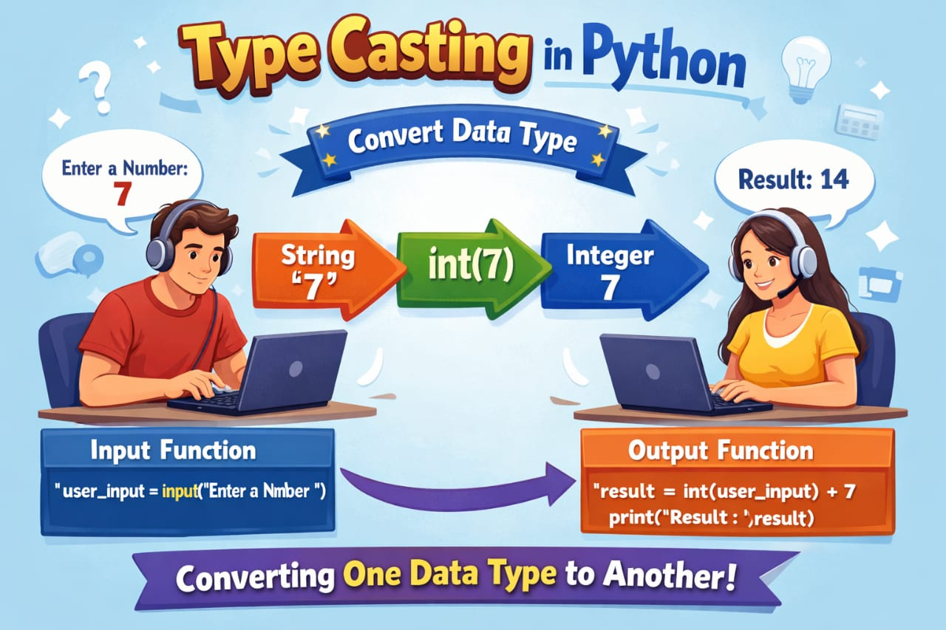
Interview Questions:
- What is type casting?
  - Converting one data type into another
- What are the types of type casting?
  - Implicit and Explicit
- What is implicit type casting?
  - Automatic conversion by compiler
- What is explicit type casting?
  - Manual conversion by programmer
- Difference between widening and narrowing?
  - Widening is safe, narrowing may lose data
- Does explicit casting cause data loss?
  - Yes

